|  |  |
| --- | --- |
| Experiment No. 6 b) Date: 28.01.2021 | 6. b) STAIRCASE WIRING |
| Name of the candidate:  Register Number:  Date of Experiment : | Debarghya Barik  RA2011026010022  28.01.2021 |

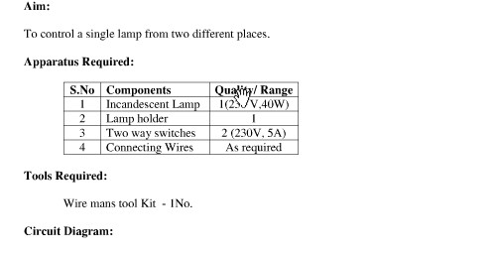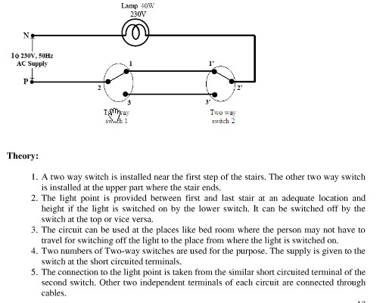

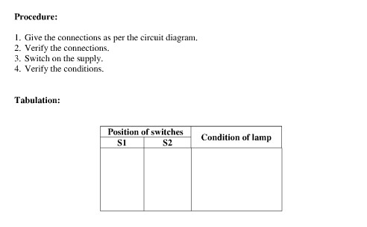

TABULATION:

|  |  |  |  |
| --- | --- | --- | --- |
| POSITION OF SWITCHES | |  | CONDITION OF LAMP |
| S1 |  | S2 |
| 1 |  | 1’ | GLOWS |
| 1 |  | 3’ | DOESN’T GLOWS |
| 3 |  | 1’ | DOESN’T GLOWS |
| 3 |  | 3’ | GLOWS |

Circuit Diagrams:

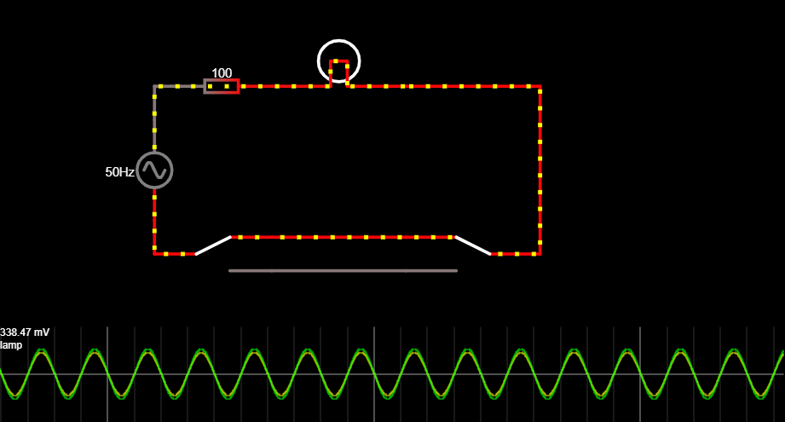

SWITCH S1 IN 1 AND S2 IN 1’ POSITION

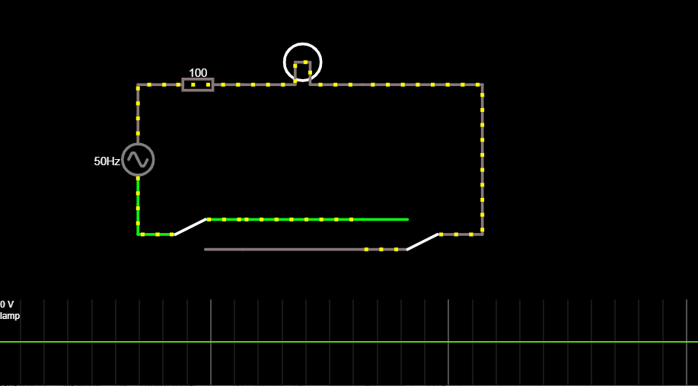

SWITCH S1 IN 1 AND S2 IN 1’ POSITION

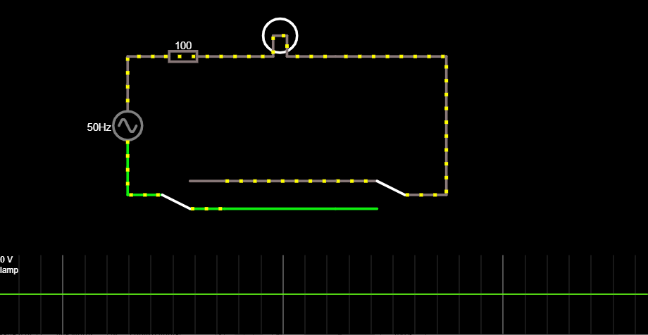

SWITCH S1 IN 1 AND S2 IN 1’ POSITION

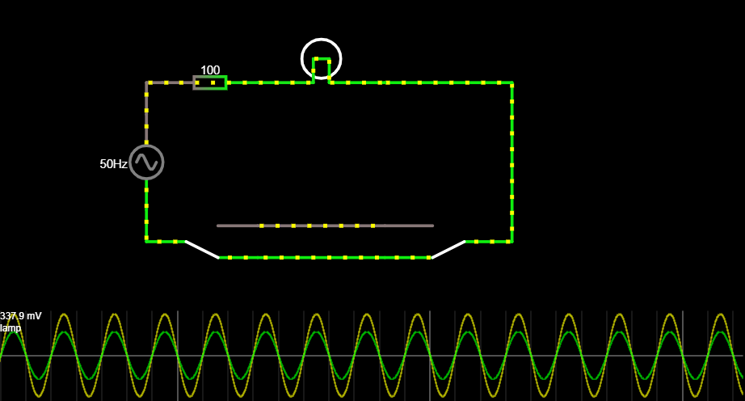

SWITCH S1 IN 3 AND S2 IN 3’ POSITION

Result: Hence, stair-case wiring is verified from the e circuit diagrams.

POST LAB QUESTIONS

1. What is the use of staircase wiring?

Ans: Staircase wiring is a common multi-way switching or two-way light switching connection where a load with two switches are used. This is done to operate the load from separate positions such as above or below the staircase.

1. Why choke is used in fluorescent lamp?

Ans: A choke is a coil of wire. The purpose of the choke is to provide a very high voltage initially (an inductive 'kick') between the filaments (across the two ends of the tube light). Again, once the gas in the tube is ionized the choke provides a low voltage.

1. What is the purpose of magnetic ballast in fluorescent lamp?

Ans: The magnetic ballast uses a magnetic transformer of copper windings around a steel core to convert the input line voltage and current to the voltage and current required to start and operate the fluorescent lamps. Capacitors are added to assist lamp starting and power factor correction.

1. Compare electronic ballast and magnetic ballast?

Ans:

|  |  |
| --- | --- |
| Electronic Ballast | Magnetic Ballast |
| 1. Electronic ballasts alter the flow of electricity in the light bulb by using a series of induction coils that are separated from one another. 2. The size of this ballast is small and light. They are also energy efficient. | 1. In contrast, magnetic ballast uses 1 induction coil and not a series. 2. They are bulkier in size and are less energy efficient. |

1. List out the advantage of staircase wiring

Ans: The advantages of staircase wiring are:

* + Easy to control appliances from various points.
  + Faster control than a single switch.
  + Highly Efficient for larger places.
  + Living Comfort can be increased.
  + Electricity can be saved.

-------------O-------------